**Generating Synthetic Data in Finance: JP Morgan AI Research**

1. Introduction:

Artificial Intelligence (AI) is transforming the financial services industry by automating processes. At J.P. Morgan AI Research, researches dedicated to developing algorithms to generate realistic Synthetic Datasets. By generating synthetic financial datasets metrics can be derived when real data is unavailable.

JP Morgan AI has embraced AI to streamline its operations and enhance quantitative edge.

Business Model:

By generating synthetic financial datasets the bank can mitigate internal data and restrict sharing. The synthetic data can be investigated and tested for macroscopic impact of disruptions to intra banking flows. Technology and Innovation also calibration methodology to apply privacy-preserving generation and tasks.

Market Landscape:

The market offers a diverse range of AI solutions tailored to the specific needs of financial institutions. Research by PYMNTS Intelligence in the “Generative AI Tracker®'' shows an uptake of GenAI in the financial sector, especially when it comes to meeting the increasing demand for personalized customer services.These solutions may include machine learning algorithms for predictive analytics, natural language processing (NLP) for sentiment analysis and chatbots, computer vision for document processing, and reinforcement learning for algorithmic trading. Jamie Dimon added that in areas like trading, with $2 trillion in securities in play each day, AI plays a major role in equity hedging.

Impact and Achievements:

JPMorgan Chase is the first major bank to roll out an AI-powered virtual assistant that will make it easier for corporate clients to move money around the world, whether it's for routine payroll or multi-million-dollar mergers and acquisitions

Challenges and Future Outlook:

AI will transform the economy over the coming decade. JP Morgan considers that the technology is at a critical inflection point: AI will be a catalyst for significant investment and associated growth across hyperscalers (leading cloud service providers), infrastructure, hardware, software and many adjacent industries.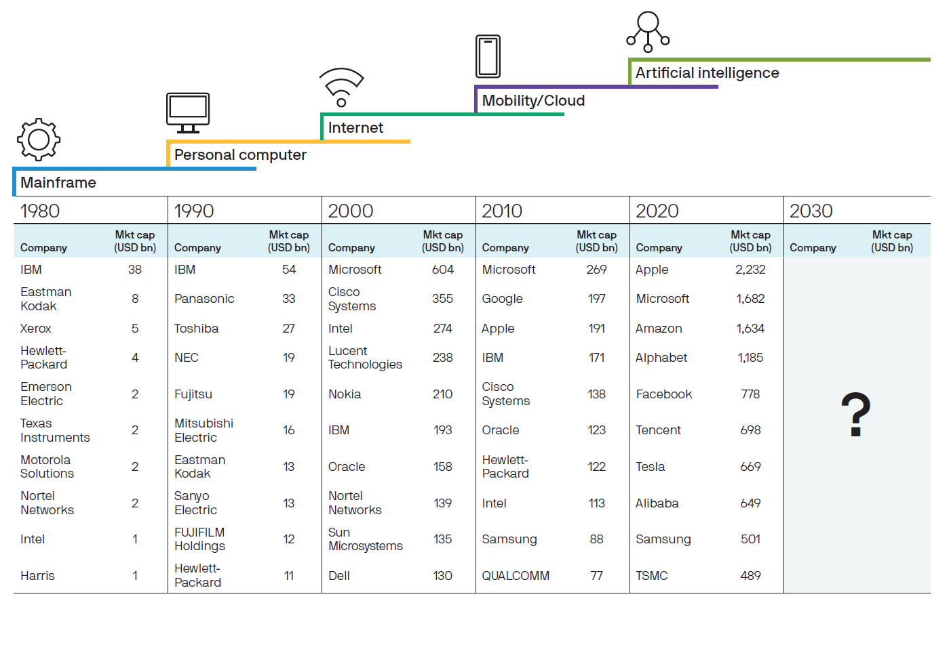

Conclusion:

In conclusion, JPMorgan’s AI-Aided Cashflow Model Can Cut Manual Work by 90%. AI technology is revolutionizing financial services and processes. Research may delve into regulatory compliance challenges facing banks and FIs, such as anti-money laundering (AML) regulations, Know Your Customer (KYC) requirements, data privacy laws, and cybersecurity standards.Research may focus on risk management practices within banks and FIs, including credit risk assessment, portfolio management, stress testing, and fraud detection.